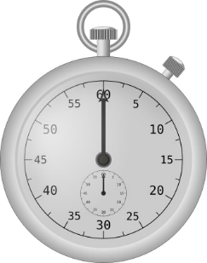
WK 4

Asking these questions at the beginning and end of each day can make a huge difference to the way we see and do things. Once you’ve answered the questions do less of the things that aren’t working and more of the things that are.

- What am I doing?

- What works?
- What does not?

These worksheets are designed to take no longer than 60 seconds to complete.
You will be amazed at what you can do in a minute.

