The Space Tapes: Inside

This is a listening & writing resource pack. It contains three writing exercises to accompany ‘The Space Tapes: Inside’ soundscape by Antosh Wojcik.

This soundscape was made to reflect elements of inside spaces. It was made from recording household objects, chats and old piano practice / band practice recordings.
It has three sections:
Ocean in my Bedroom (0:00 - 4:02)
Did You Know?! (4:03 - 7:32)
Beyond The Ceiling (7:33 - 10:11)

Listening Exercise: What can you find in the soundscape?
- Listen to ‘The Space Tapes: Inside’.
- Make notes of the senses: what you see, feel, hear, taste, smell when listening to the sounds as they develop. Describe these with as much detail as you can. These can be things found outside, anything that comes to mind is useful!
- Make note of any phrases and sensations that come to mind when listening.
- This is your Ideas Bank. You can use these ideas to build poems in the following exercises.

Writing Exercise 1: Ocean In Your Bedroom

What happens if we use elements of outside to describe an indoor space?
- Make a note of your favourite indoor space. This also doesn’t have to be in your home; it could be somewhere you can’t get too at the moment.
- Look at your Ideas Bank. Select a few ideas from outside, things you wouldn’t find in the space that you have selected.
- Write a diary entry about your favourite indoor space.
  - Write this using the elements of outside. For example, you might describe ‘the ocean of my bedroom floor is still today…’ and go on to explore what that feels like.

Writing Exercise 2: Did You Know?!

This exercise explores repetition and how it can build a shape poem.

Look at your Ideas Bank. Select a phrase and turn it into a question i.e ‘Did you know?!’ This phrase is now a Brick.
- On a blank page, build a room shape using your Brick phrase as demonstrated below.
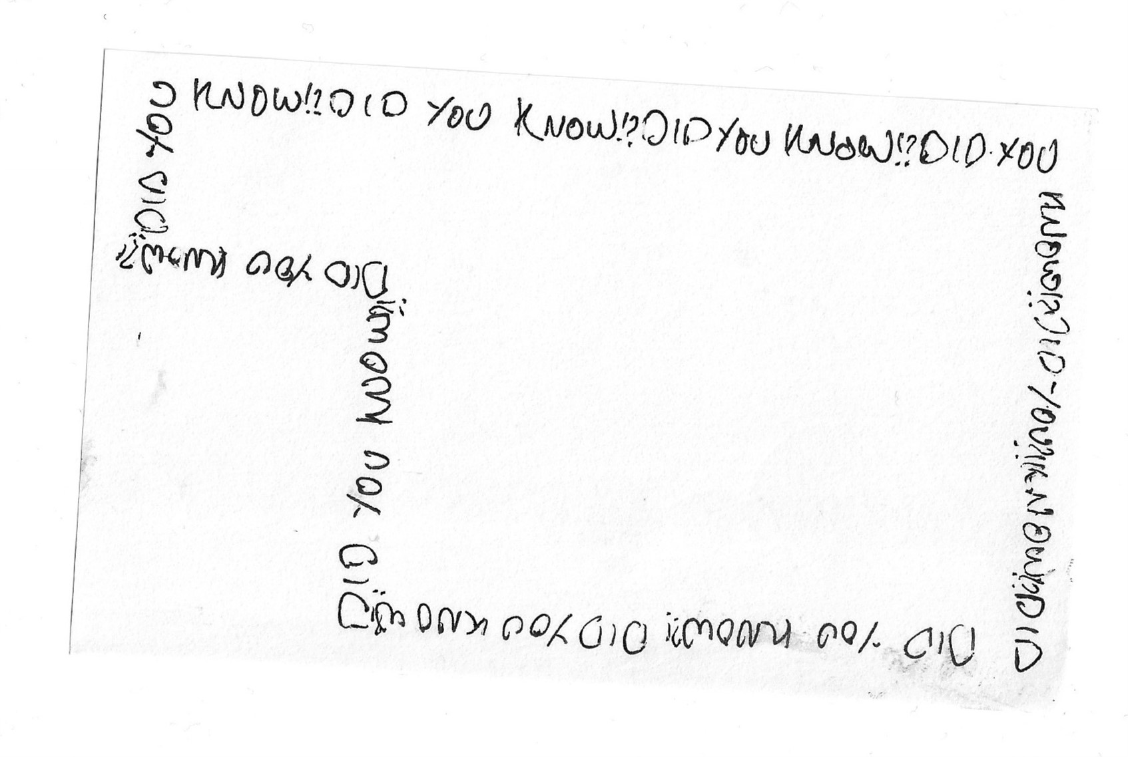
- Fill that room with ‘noise’. This noise can be made from attempts to answer the question. So, for a room of ‘Did you know?!’ I might fill it with facts and excited phrases that complete the question.
  - Think about what kind of noise your question demands. Does it make for a quiet or loud room?

Writing Exercise 3: Beyond The Ceiling - Three Constellations

Look at your Ideas Bank. Select three of your findings - these could be objects, images or feelings. These are your star constellations.
- Think about what they stand for, what they could mean for yourself or someone else. Make notes if that helps.
- Write three short poems that turn each finding into a star constellation. Bring in those ideas of what they stand for and what they could mean for someone looking up at them right now.

