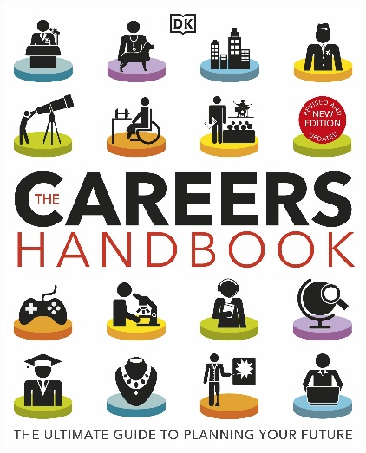

## TITLE: The Careers Handbook: The ultimate guide to planning your future.

**Authors: DK**

**Publisher:**  DK Children

**Age:** KS3/4

*Also available as an eBook*

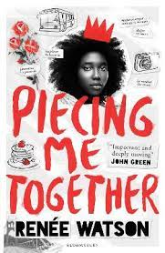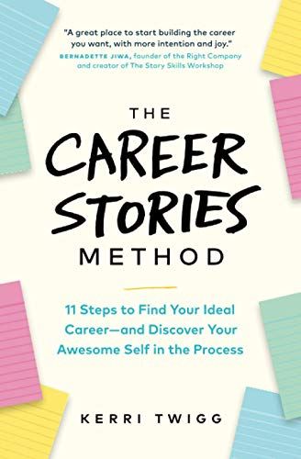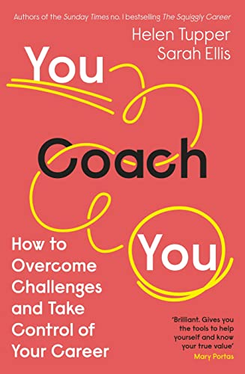

## TITLE: You Coach You- How to Overcome Challenges and Take Control of Your Career

**Authors: Helen Tupper/ Sarah Ellis**

**Publisher:**  Penguin Business

**Age:** KS3/4

*Also available as an eBook*

## TITLE: The Career Stories Method: 11 Steps to Find Your Ideal Career—and Discover Your Awesome Self in the Process

**Authors: Kerri Twig**

**Publisher:**  Page Two Books

**Age:** KS3/4

*Also available as an eBook*

## TITLE: Piecing Me Together

**Authors: Renée Watson**

**Publisher:**  Bloomsbury Children’s Books

**Age:** KS3/4

*Also available as an eBook*